**Virtual Key for Repositories**

**Project objective :**

As a Full Stack Developer, complete the features of the application by planning the development in terms of sprints and then push the source code to the GitHub repository. As this is a prototyped application, the user interaction will be via a command line.

**Sprints planned and the tasks achieved :**

* Creating the flow of the application
* Initializing git repository to track changes as development progresses.
* Writing the Java program to fulfill the requirements of the project.
* Testing the Java program with different kinds of User input
* Pushing code to GitHub.
* Creating this specification document highlighting application capabilities, appearance, and user interactions.

**Core concepts used in the project :**

* Collection’s framework
* File Handling
* Flow Control
* Exception Handling

**Unique Selling Points of the Application:**

1. The application is designed to keep on running and taking user inputs even after exceptions occur. To terminate the application, appropriate option needs to be selected.
2. The application can take any file/folder name as input. Even if the user wants to create nested folder structure, user can specify the relative path, and the application takes care of creating the required folder structure.

**Flowcharts of the application:**

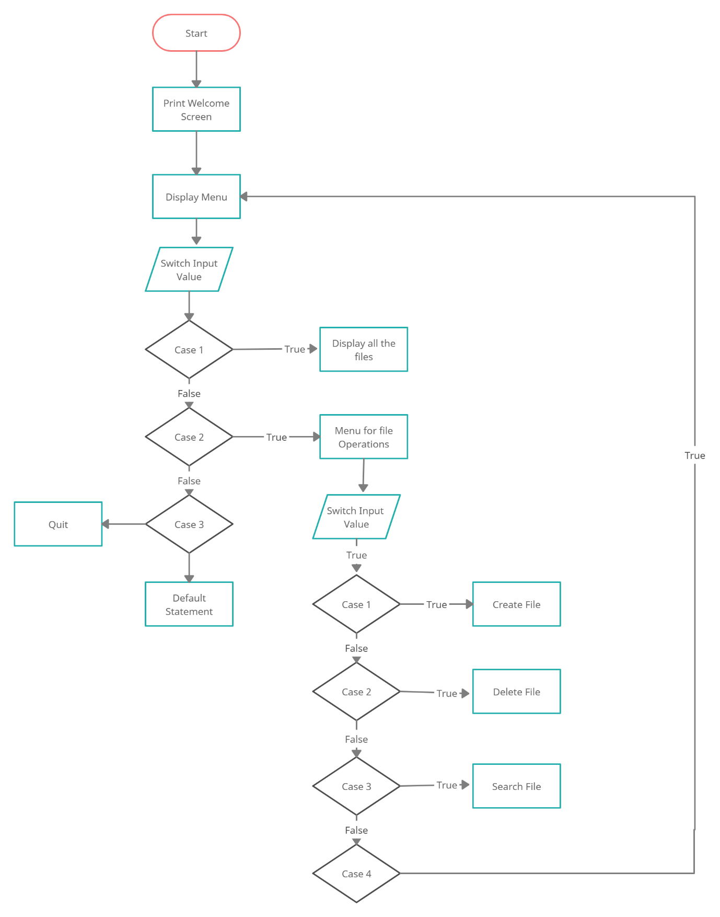

## **Conclusions:**

Further enhancements to the application can be made which may include:

* Conditions to check if user is allowed to delete the file or add the file at the specific locations.
* Asking user to verify if they really want to delete the selected directory if it’s not empty.
* Retrieving files/folders by different criteria like Last Modified, Type, etc.